Project Design Phase-II
Technology Stack (Architecture & Stack)

Date | 30 September 2026
Team ID
Project Name | AI Study Buddy API
Maximum Marks | 4 Marks
Technical Architecture:
The Deliverable shall include the architectural diagram as below and the information as per the table1 & table 2
Example: AI Study Buddy API
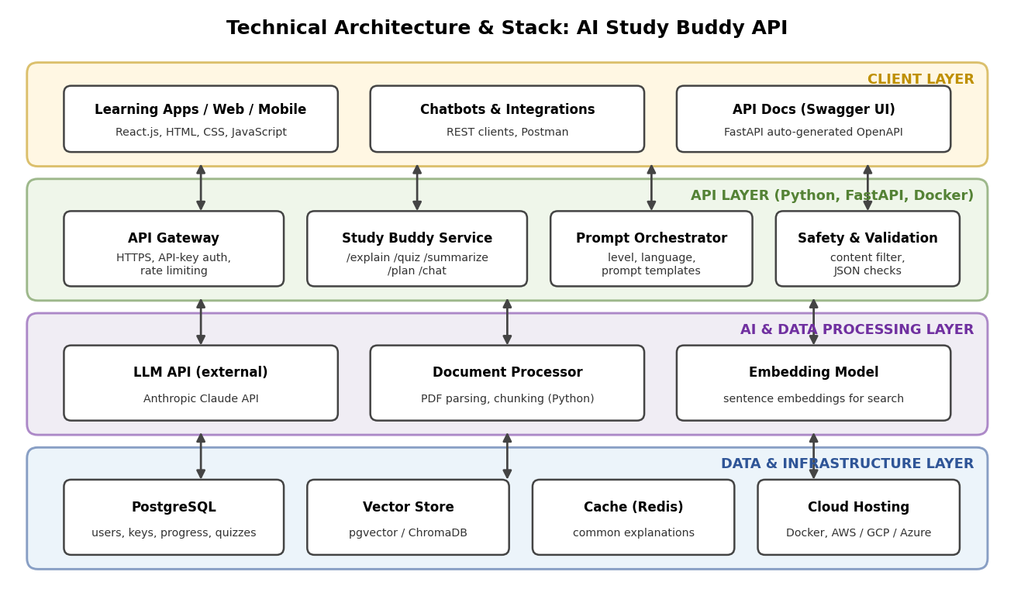
Figure 1: Technical architecture and technology stack of the AI Study Buddy API
Table-1 : Components & Technologies:
S.No | Component | Description | Technology
1 | User Interface | How users and apps interact with the API: student web / mobile apps, chatbots, and Swagger UI for developers | HTML, CSS, JavaScript / React.js, Swagger UI
2 | Application Logic-1 | Core API service with /explain, /quiz, /summarize, /plan and /chat endpoints, API-key authentication and rate limiting | Python (FastAPI, Uvicorn)
3 | Application Logic-2 | Prompt orchestrator that builds level- and language-aware prompts, plus safety and output validation | Python (Pydantic, prompt templates)
4 | Application Logic-3 | Document processor that parses PDFs and notes, splits them into chunks and creates embeddings | Python (PyMuPDF, sentence embeddings)
5 | Database | Users, API keys, usage logs, quiz history and study progress | PostgreSQL
6 | Cloud Database | Managed database service on the cloud for backups and high availability | Managed PostgreSQL (for example AWS RDS or Supabase)
7 | File Storage | Uploaded notes and PDFs | Object storage (for example AWS S3) or local filesystem in development
8 | External API-1 | Large language model that generates explanations, quizzes, summaries and study plans | Anthropic Claude API
9 | External API-2 | Email service for sending registration confirmation and alerts | SendGrid / SMTP
10 | Machine Learning Model | LLM for text generation and an embedding model for searching the student’s notes | Claude LLM, sentence-transformers embedding model
11 | Vector Database | Stores note embeddings for retrieval of relevant passages | pgvector / ChromaDB
12 | Infrastructure (Server / Cloud) | Application deployment on local system / cloud. Local: Docker Compose with Uvicorn. Cloud: containerized services behind a load balancer | Docker, AWS / GCP / Azure, Kubernetes (optional)
Table-2: Application Characteristics:
S.No | Characteristics | Description | Technology
1 | Open-Source Frameworks | Open-source frameworks used to build the API, front end and data layer | FastAPI, Pydantic, React.js, PostgreSQL, pgvector, Docker
2 | Security Implementations | HTTPS/TLS, API keys stored hashed, input validation, rate limiting, secrets in environment variables, safety filter on outputs | SHA-256, TLS, IAM controls, OWASP API Security Top 10
3 | Scalable Architecture | Stateless microservice-style API in containers, so more instances can be added as traffic grows; LLM provider can be swapped | Docker, load balancer, 3-tier architecture
4 | Availability | Multiple API instances behind a load balancer, health checks with automatic restart, managed database with backups | Load balancer, managed PostgreSQL, container health checks
5 | Performance | Caching of common explanations, asynchronous request handling, PDF processing in the background, target response time under 5 seconds | Redis cache, async FastAPI, CDN for front end and docs
References:
https://c4model.com/
https://developer.ibm.com/patterns/online-order-processing-system-during-pandemic/
https://www.ibm.com/cloud/architecture
https://aws.amazon.com/architecture
https://medium.com/the-internal-startup/how-to-draw-useful-technical-architecture-diagrams-2d20c9fda90d

